Employability Shared Measurement Framework – Key Questions

Summary

The Shared Measurement Framework (the framework) aims to create a coherent approach to measurement across employability support, and is one of the key deliverables required in order to fully realise the principles of No One Left Behind. This paper sets out recommendations for which ‘key questions’ the framework should address. These key questions will be answered using data collected from all organisations delivering employability services through the No One Left Behind approach. These questions are the foundation for a consistent approach to measuring the success of employability programmes and services.

The Key Questions have been developed in partnership between Scottish Government, Local Government, Third Sector and Private Sector though a range of governance groups and engagement. Therefore, this paper reflects the collective view of those consulted of what we all need to know about employability services, at national, local and individual service levels, using data collected by employability services.

During the next stage of development, we will collectively identify the data that will need to be gathered across employability services to answer the Key Questions.

- Policy context: No One Left Behind

No One Left Behind outlines a new approach to funding and delivery of employability services. It signals a shift from a top down programme approach, where target groups and provision are set out at a national level, to one where local areas have the flexibility to use funding in line with the needs of their local community.

On 5th December 2018, the Scottish Government (SG) and the Convention of Scottish Local Authorities (COSLA) signed a Partnership Working Agreement for Employability. This aims to drive co-operation, integration and alignment between national and local employability services in Scotland, establishing a joint commitment to deliver the objectives of No One Left Behind. The Partnership Working Agreement places both Local and National Government as being jointly accountable for delivering this system change.

Reflecting the multiple sectors involved in delivering employability services, the development and delivery of No One Left Behind requires a partnership approach. The workstreams and products being developed to support local partnerships in delivering No One Left Behind, including the framework, are being developed collaboratively involving public, private and third sector partners.

The No One Left Behind commitments, including a requirement to align and streamline data collected across services, are set out in the following publications:

- No One Left Behind: Next Steps for the Integration and Alignment of Employability Support in Scotland (March 2018)
- No One Left Behind: Review of Employability Services (December 2018)

These commitments are designed to support services and local partnerships to create a system based on the following principles:

- Dignity and respect, fairness and equality and continuous improvement
- Provides flexible, and person-centred support
- Is straightforward for people to navigate
- Integrated and aligned with other services
- Provides pathways into sustainable and fair work
- Driven by evidence including data and experience of others
- Support more people to move into the right job, at the right time.

- Shared Measurement Framework

The framework will play a key role in enabling the development of a system which is ‘driven by evidence, including data and the experience of users’, and will support a shift from separate approaches to measurement for different employability programmes, to a coherent view of what is working for people at a national, local and individual service level.

The framework will have a number of component parts:
- Key Questions relating to five themes; Reach, Progression, Skills Alignment, Experience of Services and Value of Services. These are the questions that every employability service should be able to answer; and
- information about the data which should be collected to answer the key questions

The data gathered through the framework will be used by those delivering the No One Left Behind approach to employability service delivery, ensuring people are placed at the centre of decisions around, planning, commissioning and improvement of employability services.

The Scottish Government, in partnership with organisations from across the wider employability sector, has worked to develop the themes and key questions for the framework, through an initial survey and follow up workshops, reaching a broad range of people from Key Workers to Directors. Annex A provides more detail on how engagement with partners to support development of the framework has been undertaken to date and Annex B provides a list of the Shared Measurement Framework Development Group members.

Feedback from engagement showed strong support for the five overarching themes of the framework and the key questions. This provides assurance that there is a shared view on what we all need to know about employability services across a variety of roles and organisations within the employability sector.

Given our wider commitment to the Scottish Approach to Service Design, users also had a significant voice in shaping elements of the framework. In creating the questions for the “Experiences of Services” theme, we worked closely with our Lived Experience Panel, which has been central to the on-going development of the No One Left Behind Customer Charter. This had the benefit of giving users a space to tell us what was important to them, whilst also building on the Charter Commitments, creating a strong alignment between the two products.

Themes and Key Questions

The themes and Key Questions are set out in the table below. Whilst these are the product of collective development and agreement with partners from across the employability sector, it is possible the questions presented here could be refined during the development of the framework, as we collectively explore the data which should be collected to answer the key questions.

Furthermore, as we further develop other products that will support the implementation of No One Left Behind, such as the Service Standards Framework, Evaluation Plan and Continuous Improvement Strategy, it may be necessary to refine the wording presented below to ensure coherence between the framework and other outputs.

Theme | Description | Key Questions
Reach | To ensure employability services are reaching all those who need support to progress towards, move into and sustain fair work. | 1.1 Who needs support in our community?  1.2 Who are we reaching and what challenges do they face?  1.3 Are people actively engaged with support?  1.4 Who are we not reaching?
Progression | To enable an individual’s progression towards fair work and sustained employment. Considering aspects such as improving well-being, confidence and motivation, maintaining or re-engaging with support, and developing aspirations and skills. | 2.1 Are people progressing, if so, in what ways?  2.2 Are people’s goals/milestones being achieved within the expected timeframe?  2.3 Have people entered and sustained education, training or employment?
Skills Alignment | To ensure participants are being supported to develop skills, knowledge and experience that are needed now, and in the future. | 3.1 What relevant skills, knowledge and experience are people developing as a result of our support?
Experience of Services | To ensure that people accessing services are treated with dignity and respect, and experience support which is accessible, aligned with other services and responsive to their needs. | 4.1 Are we treating people with dignity and respect?  4.2 Do clients receive a tailored service that supports their individual journey?  4.3 Do clients find the service easy to access?
Value of Services | To understand whether we are making the best use of resources invested, maximising value for participants and contributing to local and national policy ambitions. | 5.1 How and in what ways do employability services contribute to national and local priorities?  5.2 What is the value for money of our investment?

Next Steps

The themes and key questions set out here provide the initial structure of the framework, setting out what we collectively value and the questions we want to be able to answer to demonstrate that employability services are working for service users.

More work is required to fully develop the framework. Working with partners over the coming months Scottish Government will:

- Develop the data required to answer each key question, learning from what is already in place, identifying any gaps, and working with service providers to identify and start to implement any required changes to existing data collection
- Agree key operational definitions, ensuring that the terminology included in the framework is commonly used and understood
- Begin to scope out putting the framework into practice, including aligning it with other national products in development in order to avoid duplication or added pressures on those delivering services.

Annex A: survey respondents, workshop participants and lived experience panel

Survey
The survey received thirty-four individual responses. Of these thirteen were from key workers, twelve from service / programme managers, five from directors, and two from senior administrators (two respondents did not provide sufficient information and their role was unknown).
The survey contained a series of open questions regarding five key areas: reach; progression; skills alignment; experience of service; and value of service. For each of these areas, the respondents were asked
a) Would these questions be important for you in your role, and if so, why? Would you change them in any way?
b) Are there any other questions you ask when you look at data relating to reach? I.e. what else do you need to know?
c) How does getting answers to the questions above help you in your role i.e. what do use the data for?
d) What would the implications be if you couldn’t answer these questions? and
e) What would the implications be if you couldn’t answer these questions?
For the respondents, the local authority areas with the most coverage by respondent’s organisations were mostly in Glasgow and the surrounding area (Glasgow City had 36% coverage, South and North Lanarkshire both 27%), with South Ayrshire, Perth and Kinross, Fife, Dundee City and Angus all having 21% coverage.
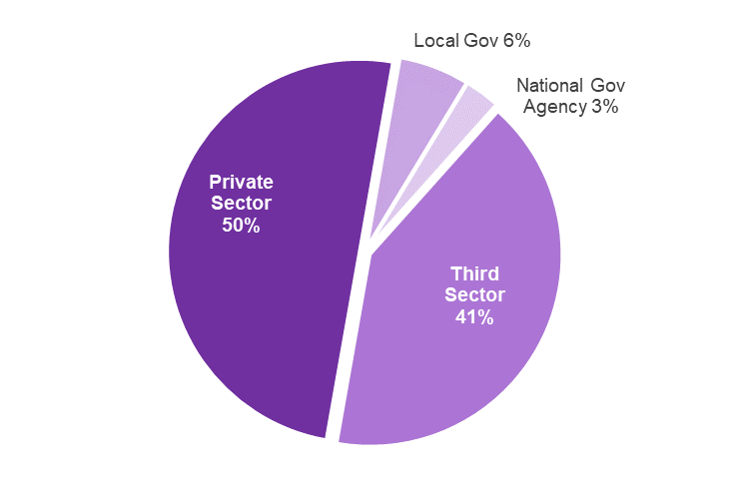
The bulk of the respondents were from the private sector (50%) and third sector (41%). The remaining respondents were from local government (6%), and national government agency (3%) (Figure 1)
Figure 1: Survey respondent sectors
Workshops
Workshop participants came from a wide range of organisations from across sectors, which differed in size, location and service user group. Participants included those in frontline operational roles, such as key workers and service managers, to those in senior management and more strategic roles, from the following organisations:

Access to industry
Action For Children
Apex Scotland
Barnardos
Calman Trust
Cemvo Scotland
Cothrom
Cyrenians
East Ayrshire Carers Centre
Enable Scotland
Fare Scotland
Glasgow Caledonian University
Libertie
Move On
NHS Lanarkshire
North Lanarkshire College
One Parent Families Scotland
Project Scotland
Routes to Work
Rural and Urban Training Scheme (RUTS)
SAMH
Scottish Council for Voluntary Organisations
Scottish Refugee Council
Senscot
Springboard UK
Stirling Community Enterprise
Stirling Community Media
Street League
The Auchindrain Trust
The Lennox Partnership
The Princes Trust
Unlock Employment
Venture Trust
Via Scotland
Who Cares Scotland
Youth Community Support Agency
YouthLink Scotland
Lived Experience Panel

The Lived Experience Panel was set up in September 2020 by the Scottish Government’s Employability Division with the initial aim of co-designing a Customer Charter for No One Left Behind which clearly sets outs what users can expect from services. It was subsequently decided to utilise this panel in February 2021 to ensure that the user voice was captured as part of the development of the Experience theme. The panel included people from a wide range of backgrounds whose experiences would be beneficial in shaping the framework.

The panel was intended to represent the people that would be using the service. As such, criteria for membership was considered carefully with the decision ultimately taken to keep this as wide as possible to prevent exclusion. In line with No One Left Behind priority groups, we reached out to Third Sector and Local Authority colleagues to help identify participants that fit into these broad groups:

- People from Minority Ethnic communities
- Disabled people
- People with a history of addictions
- Refugees
- People with experience of Homelessness
- Lone parents
- People with a history of offending
- Young people
- People with experience of mental health
- People living in rural areas
- Care experienced people and carers

Given the physical distancing restrictions that were in place this Panel took place digitally via video conferencing software. This proved beneficial particularly in that it allowed a wider geographical representation without the need for travel.

The session was designed to allow panel members to contribute to the development of the Experience theme for the framework. This approach allowed those in attendance to pose questions they believe employability services should be asking themselves, adding value to the development process by highlighting where things could be improved and what is important to measure from the perspective of someone using a service.

This approach also allowed us to link this theme of the framework with the Customer Charter that is currently being developed by the panel, driving alignment of these products and ensuring a consistency of purpose.

Annex B: Shared Measurement Framework Development Group members

Name | Organisation
Pamela Smith | Improvement Service
Hannah Young | Improvement Service
Sam Tennant | Improvement Service
John Davidson | Dundee City Council
Ceilidh Rosbotham | Renfrewshire Council
Ruth Cooper | Renfrewshire Council
Laura Neill | Renfrewshire Council
Clare Stewart | West Lothian Council
Jane Adamson | Clackmannanshire Council
Matthew Heap | Capital City Partnership
Nick Downes | Skills Development Scotland
Taylor Stewart | Skills Development Scotland
Louise Stevenson | Inspiring Scotland
Pegs Bailey | Five Voluntary Action (Third Sector Employability Forum representative)
Jayne Chappell | Social Enterprise Network Scotland (Third Sector Employability Forum representative)
Amy Stuart | Scottish Government
Christopher O’Hanlon | Scottish Government
Kirsty MacLean | Scottish Government
Arfan Iqbal | Scottish Government
Neil Davidson | Scottish Government
Osian Morgan | Scottish Government
Sarah Trotter | Scottish Government
Helen Harper | Scottish Government
Kerry McInally | Scottish Government
Jenny Gemmell | Scottish Government
Ellie Crawford | Scottish Government
Robert McGregor | COSLA

