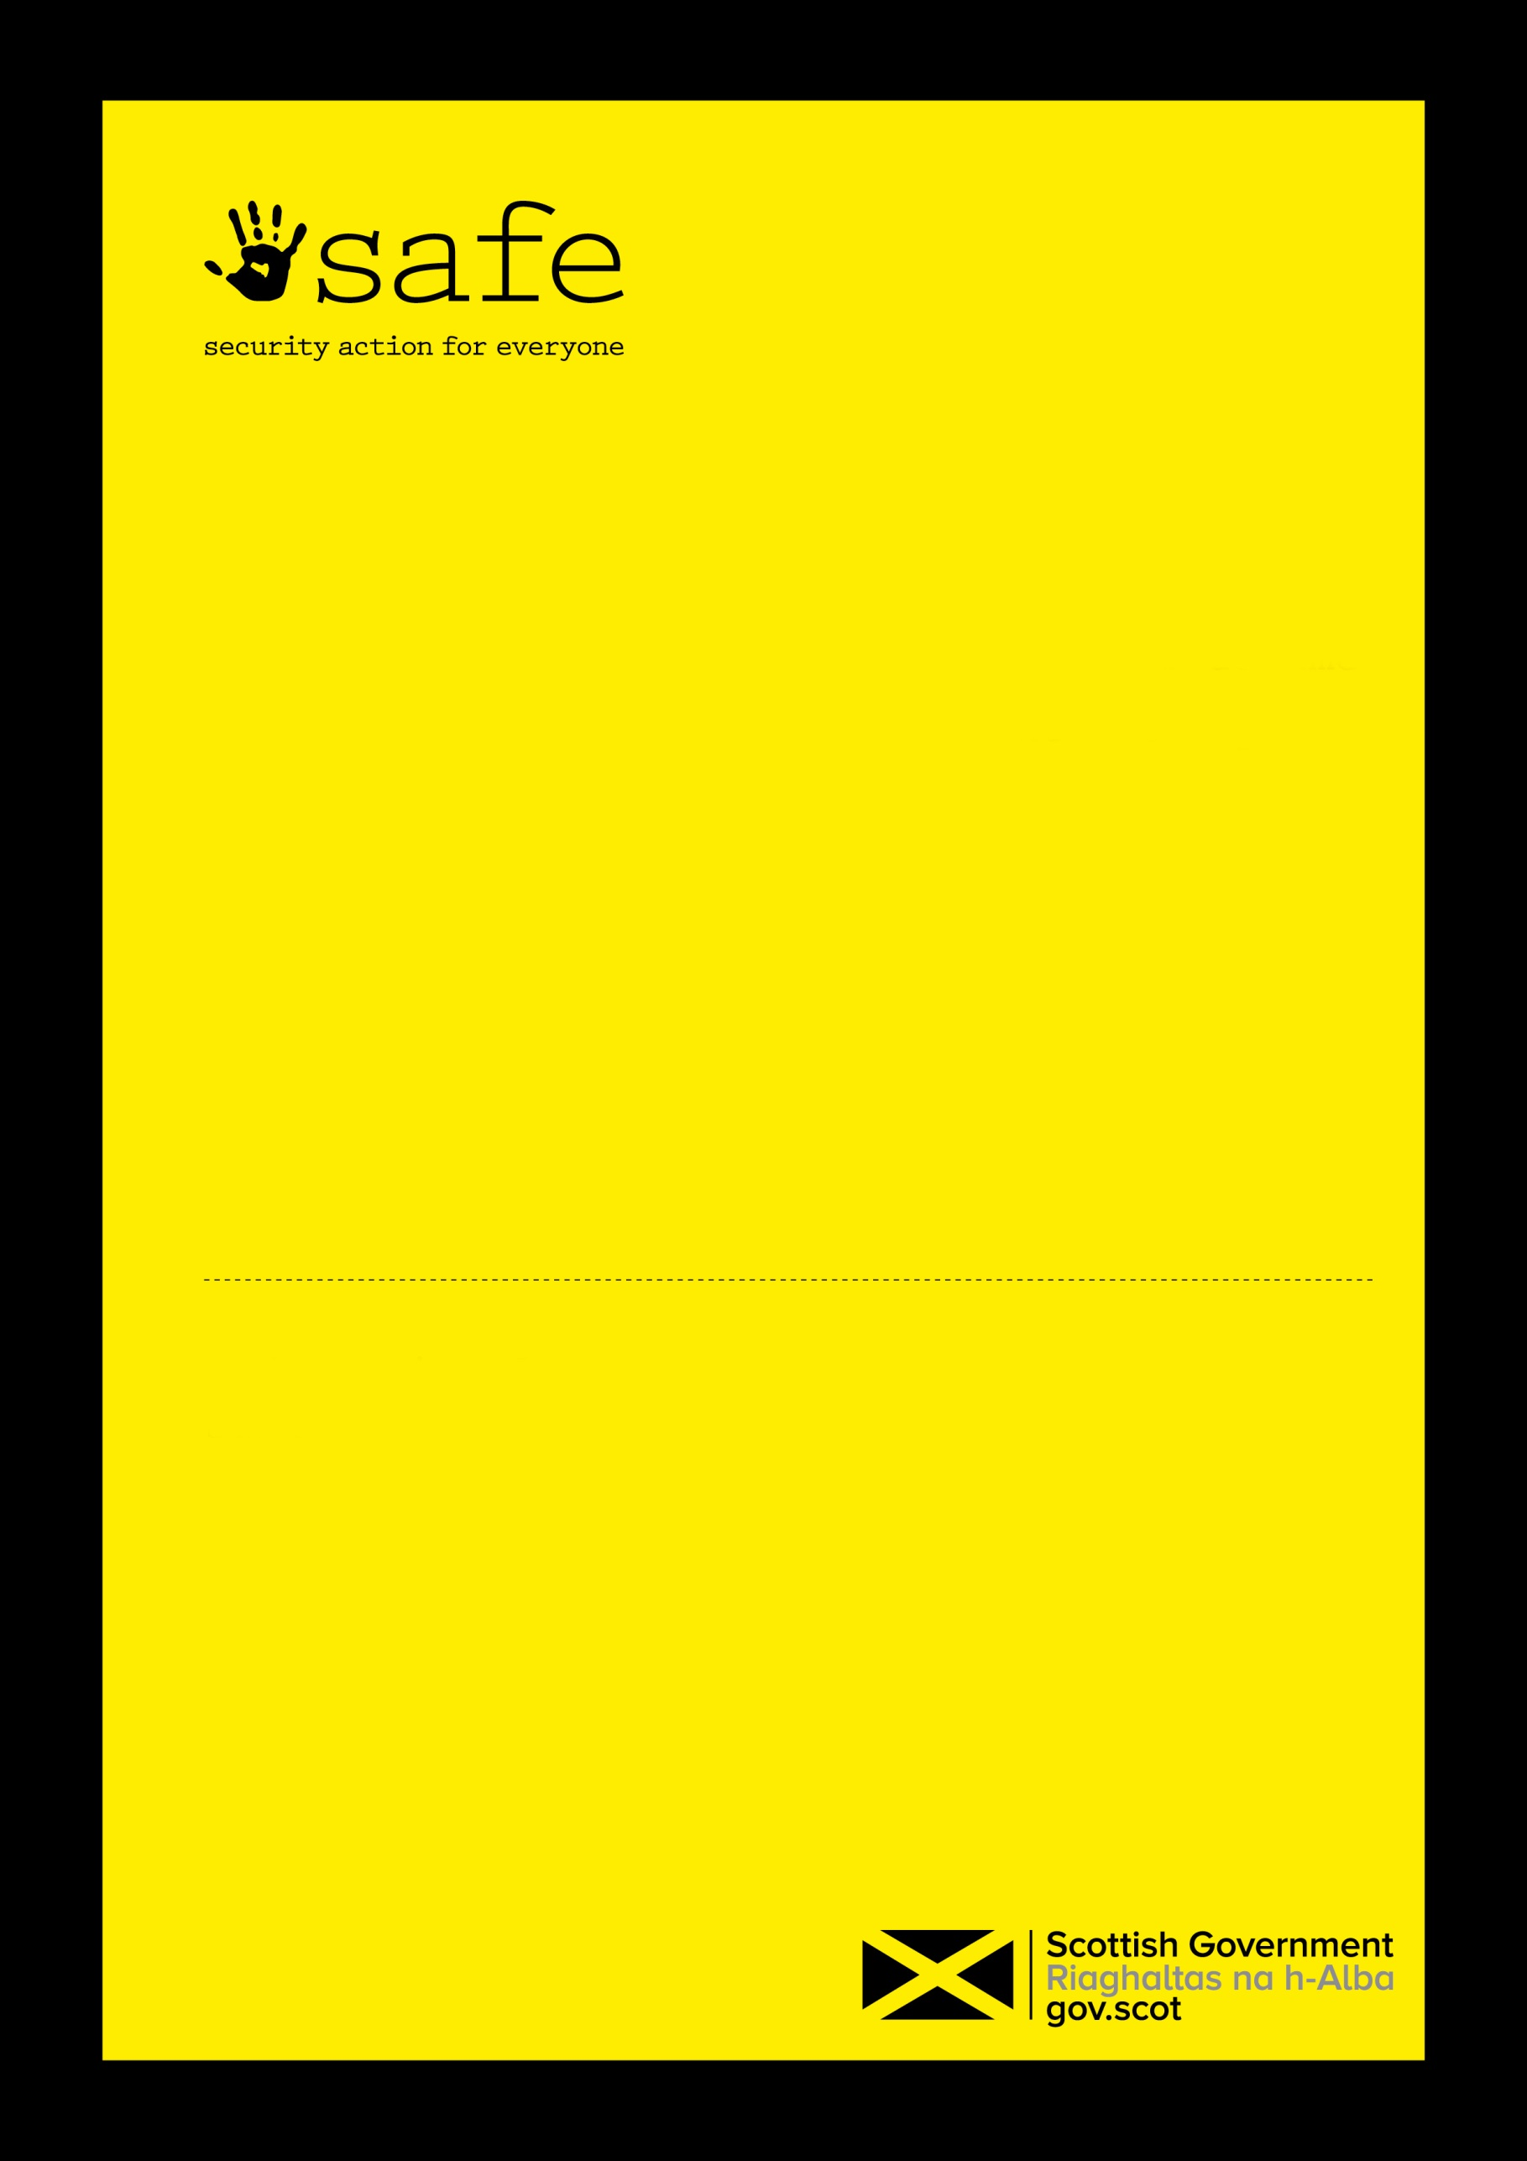
Master version in Library - eRDM Objective ID (if applicable) | Axxxxxxxxx
October 2022
Information Assurance and Risk
Data Sharing Agreement
Personal data

Data Sharing Agreement

For the necessary sharing of participant data between

Scottish Government

and

[insert relevant local authority]
Contents
1. Introduction 4
2. Organisations involved in the data sharing 4
3. Purpose(s) of the data sharing 4
4. Aims and benefits 5
5. Relationship between the Parties 5
6. Data to be shared 5
7. Further disclosure 6
8. Data to be matched or linked 6
9. Process for sharing 6
10. Format of data 6
11. Frequency of transfer 6
12. Access restrictions 7
13. Legal gateway (also known as the power to share data) 7
14. Lawful basis for processing 7
15. Information assurance and security 7
16. Management of a security incident 8
17. Freedom of Information Requests 8
18. Subject Access Requests (SAR) 8
19. Data Protection Impact Assessment (DPIA) 8
20. Privacy notices 9
21. Retention & deletion 9
22. Commencement 9
23. Review & changes to agreement 9
24. Term and Termination 9
25. Signatories 9
Appendix A - Glossary of terms 11
Appendix B – Data Specification Template 11
Appendix C – Data Protection Impact Assessment 11

Introduction

This Data Sharing Agreement (the Agreement) has been set up to provide standardised and agreed upon good practice between Scottish Government and Local Authorities, regarding the on-going secure transfer of service users data from Scottish Government funded local employability support services that are managed and delivered by [INSERT NAME OF LOCAL AUTHORITY] (the “Local Authority”) on behalf of the Scottish Government.

This Agreement documents the lawful basis for the data sharing required by these arrangements, together with the principles and processes for securely exchanging and using information. All Parties agree to observe all the obligations set out in this Agreement.

Personal data shall be processed in a manner that ensures appropriate security of the personal data, including protection against unauthorised or unlawful processing against accidental loss, destruction or damage using appropriate and technical measures as per the UK General Data Protection Regulation (UK GDPR) security principle.

This Agreement will commence when the final version has been signed by or on behalf of both Parties.

Organisations involved in the data sharing

Organisation/business area | Scottish Ministers (Scottish Government)
Information Asset Owner (IAO) | Joanne Farrow
Operational contact name | Shona Smith
Operational contact job title: | Statistician, Office of the Chief Economic Advisor: Employability Analysis

Organisation/business area | [insert council name]
Information Asset Owner (IAO) (if applicable) | [insert named person from council]
Operational contact name: | Employability Lead
Operational contact job title: | Employability Lead Officer

Purpose(s) of the data sharing

The purpose of the data collection covered under this agreement will enable Scottish Ministers, Local Authorities, other public bodies, relevant stakeholders and the general public to monitor how Scottish Government funded local employability support services are being implemented and the extent to which they are reaching their stated aims. It will also provide evidence to help with the development or refinement of policies, programmes and services designed to improve outcomes for those seeking sustainable employment.

There is a need for individual level data to be shared as it will allow for more in-depth cross-sectional analysis across a wide range of characteristics and experiences that would not be possible with aggregate data. This enables greater statistical and analytical value to be drawn from the data.

There is also an implied power to process and share data that is provided to Scottish Government from other sources, including information obtained directly from Scottish Government funded local employability support services, for the purposes of giving effect to arrangements made under Section 2 of the Employment and Training Act 1973 and Education 1999 regs.

Scottish Government funded local employability support services also promote a strengthened partnership approach where the spheres of government work more collaboratively with third and private sectors to identify local needs and make informed, evidence-based decisions, flexing these to meet emerging labour market demands.

Aims and benefits

No One Left Behind is our approach to transforming employment support in Scotland. It has a crucial role in achieving our vision for economic transformation and tackling child poverty; and aims to deliver a system that is more tailored and responsive to the needs of people of all ages who want help and support on their journey towards and into work - particularly people with health conditions, disabled people and others who are disadvantaged in the labour market.

Scottish Government will use data provided by the Local Authority for the purposes of providing briefing to Scottish Ministers, to produce regular statistics, and to provide evidence for monitoring and evaluative purposes in order to and make informed, evidence-based decisions, and adhere to the principles of continuous improvement which underpins the approach.

This Agreement also adheres to the principles of partnership approach between Scottish Government and Local Authorities to delivering employability services. Both the Scottish Government and local authorities will benefit from this partnership by allowing for easier identification of what works, and reduction in duplication of services locally, and an increase in the accessibility of services across the local area due to the easier navigation experience of participants.

This data shared is also crucial for the development of the Shared Measurement Framework (SMF). The SMF will play a key role part in delivering one of the No One Left Behind objectives of being driven by evidence, including data and the experience of users.

Relationship between the Parties

The Parties agree that the relationship between them is such that the sharing of the data is on a data controller to data controller basis.

Each Party agrees that it is a separate and independent data controller in respect of the data that is processed under this agreement and that the parties are not joint data controllers or data controllers in common.

Each Party is responsible for ensuring that its own processing of the data is compliant with data protection legislation.

Data to be shared

The data to be collected under this agreement is subject to changes and modifications as the employability support service landscape develops over time. Any changes would only be made after consideration through relevant governance processes (e.g. Data Reporting Group) and dialogue with relevant stakeholders in the partnership agreement.

The data to be submitted for quarterly publication by Scottish Government is included in Annex B. For the purposes of independent evaluation of No One Left Behind the following Data Categories may be requested: ‘address’, ‘phone number’ and ‘preferred method of contact’.

Further disclosure

Requests made to the Scottish Government pertaining to this agreement will be assessed by the Scottish Government to ascertain whether providing the data would be of public benefit and if the requester has been adequately trained for handling sensitive data, and that adequate security is in place for handling the data. In addition, where relevant, requests will be fully assessed by the Scottish Government Statistics Public Benefit Panel Process. If assessed to be relevant, the Scottish Government will consult with the relevant Local Authorities as required. Any data that would be disclosed must only be for research or statistical purposes and all information that identifies individuals would be removed and adhere fully to UK GDPR regulations. The Scottish Government will transfer the data securely to the researchers.

Data to be matched or linked

If the Scottish Government receives any applications to link this data then this will be done under the Data Linkage Framework for Scotland. Only where the data is being linked for statistics and research purposes would such requests be considered.

Process for sharing

Data returns are submitted by all 32 Local Authorities using an agreed-format Excel spreadsheet or CSV file, to an Objective Connect folder that will be used to receive the data. Access to this folder will be restricted to analysts processing the data, and each Local Authority will have access to their own sub-folder within this, with access limited to a small number of colleagues in charge of providing the data. The raw data are then saved onto a folder on eRDM. CSV files of only the relevant data sheet from each LA are then saved onto a datashare folder, ready for import into SAS, the system used for statistical analysis. Access to the eRDM folder, datashare folder and the SAS libraries are also restricted to a specific group of analysts only.

Format of data

Local Authorities and Scottish Government agreed the format of data outlined in the Data Specification Template to be shared so that this is compatible with systems used by both organisations and be subject to change where necessary and agreed upon by the relevant parties e.g. Date of Birth being recorded in a standardised and consistent way.

Frequency of transfer

Data returns from the Local Authorities will be provided to Scottish Government on a quarterly basis. Data may also be requested on an ad hoc basis or more frequently than once every quarter, depending on operational or data-driven requirements, on an ongoing basis, but only where agreed upon in advance through dialogue with relevant governance groups.

Access restrictions

Access to data will be limited to named officials within Scottish Government.

The Scottish Government shall ensure that all employees with access to the No One Left Behind data:

are informed of the confidential nature of the data

have undertaken training in the laws relating to handling personal data

are aware of their duties and obligations under such laws and this agreement

Legal gateway (also known as the power to share data)

There is an inherent power based on the Scotland Act 2016 Section 31; Section 2 of the Employment and Training Act 1973, and regulation 2(c) of the Educational Development, Research and Services (Scotland) Grant Regulations 1999/65 to process data for the purposes of administering, monitoring and improving employment services such as those under No One Left Behind.

Lawful basis for processing

The parties are satisfied that this data sharing meets the lawful basis for processing under Articles 6(1)(c) and 6(1)(e) of the UK GDPR: For the Local Authorities this would be:

processing is necessary for compliance with a legal obligation to which the controller is subject

and for the Scottish Government this would be:

processing is necessary for the performance of a task carried out in the public interest or in the exercise of official authority vested in the controller;

Additionally, as “Special Category Data” (as defined by the UK GDPR) are also being processed, both parties are satisfied that it is shared subject to Article 9(2)(j) of the UK GDPR:

processing is necessary for archiving purposes in the public interest, scientific or historical research purposes or statistical purposes in accordance with Article 89 (1) based on Union or Member State law which shall be proportionate to the aim pursued, respect the essence of the right to data protection and provide for suitable and specific measures to safeguard the fundamental rights and the interests of the data subject.

Information assurance and security

All Scottish Government staff are required to undertake baseline personal security standards as the vetting standard for all Scottish Government staff. All staff must complete specific e-learning and online packages specially for security and data protection. The Local Authority will operate a similar approach.

All Scottish Government buildings have restricted access and Government ID cards must be worn at all times. The Local Authority will operate a similar approach. All Visitors to the organisation must be signed in by a core member of staff and escorted through the premises at all times.

All datasets are transferred from the delivery mailbox to a restricted access folder in the Scottish Government’s electronic records management system, e-RDM until it is no longer needed, at which point it is deleted. The data is processed using the SAS statistical software package, and is held on secure SAS servers. Individual level data will only be accessible by a limited group of statisticians in the Scottish Government, along with server administrator, who have all been trained in the safe handling of data. Access is controlled at two levels:

- At the operating system level, using Windows Access Control Lists to grant access to the members of approved Active Directory security groups.
- Within SAS metadata, using SAS Access Control Templates to grant access to the members of groups defined in the metadata.

These servers are hosted in one of two data centres and can only be accessed from the internal Scottish Government network, known as SCOTS. The primary data centre is at Saughton House, a Scottish Government building in Edinburgh.

The data is held on a Storage Area Network (SAN) physically located in the primary data centre in Edinburgh. This data is also replicated to a SAN in the secondary data centre which is located in the Kaird, Hamilton, Scotland, and additionally backed up every weekend to separate storage in the primary data centre.

Management of a security incident

In the event of any potential data breaches or significant security risks affecting the shared data, the Scottish Government shall inform the relevant Local Authority contact as stipulated in Section 2 within 48 hours, and, without prejudice to any other right or remedy, the relevant Local Authority may terminate this agreement with immediate effect by giving notice to the Scottish Government in writing.

The Scottish Government operational contact will also report the security incident to the Scottish Government Data Protection and Information Asset team immediately after becoming aware of the incident. If the breach is a reportable breach, the Scottish Government will also notify the Information Commissioner’s Office within 72 hours of becoming aware.

Freedom of Information Requests

The Parties shall co-operate in handling and disposing of any requests made to either of the Parties, under the Freedom of Information (Scotland) Act 2002, of the other. The Parties acknowledge that nothing in this agreement is confidential.

Subject Access Requests (SAR)

The Parties shall comply with any obligation incumbent upon it, to the extent it applies under Article 15 of the UK GDPR.

Data Protection Impact Assessment (DPIA)

A DPIA was originally carried out in 23.01.2019 and refreshed in 22.06.2022, which considered the various impact of the data collection of data protection and privacy that might be impacted by this data collection. The completed DPIA can be viewed below within Appendix C.

Privacy notices

Local Authorities will have in place Scottish Government provided appropriate Privacy Notices to inform individuals of the use of their data or their own which will be of equivalent standard and content.

Retention & deletion

The Parties acknowledge that the data will be processed for monitoring and evaluation purposes to allow the production of Scottish Government statistical and research publications..

The storage limitation principle (Article 5 (e)) states that personal data may be stored for ‘longer periods’ insofar as the personal data will be processed solely for archiving purposes in the public interest, scientific or historical research purposes or statistical purposes in accordance with Article 89 (1) subject to implementation of the appropriate technical and organisational measures required by the UK GDPR in order to safeguard the rights and freedoms of the data subject.

Commencement

The agreement will commence on date of sign off by both parties. This Agreement can be extended with the written agreement of both parties.

Review & changes to agreement

Except expressly provided in this agreement, no variation of this Agreement shall be effective unless it is in writing and signed by both parties. Reviews can be carried out as required, subsequent to the agreement of both parties, but not later than the closure of this agreement, as stipulated in section 24. This Agreement can be changed with the written agreement of both parties outlined in Section 2 and within two weeks of change being agreed.

Term and Termination

This Agreement will close on October 2027 unless, following a review of the terms of the Agreement, the parties agree to extend the Agreement.

Either Party may terminate this Agreement at any time on giving 30 days' notice in writing to the other party.

Signatories

By signing this agreement the Parties confirm that they accept its terms.

Organisation/business area: Scottish Ministers (Scottish Government)………………
Information Asset Owner (IAO) name: Joanne Farrow……………………………
Signature……………………………………………………. Date 03/10/2022…………

Organisation/business area: ……………………………………………………
Information Asset Owner (IAO) name: …………………………………………
Signature……………………………………………………… Date…………….

Appendix A - Glossary of terms

DPIA | Data Protection and Information Assets
The Agreement | Data Sharing Agreement
GDPR | General Data Protection Regulation
IAO | Information Asset Owner
SMF | Shared Measurement Framework
SAN | Storage Area Network

Appendix B – Data Specification Template

Appendix C – Data Protection Impact Assessment

Scottish Government statistics: request our data - gov.scot (www.gov.scot)
http://www.scotland.gov.uk/Topics/Statistics/datalinkageframework

