EMPLOYABILITY SERVICE STANDARDS

Table of Contents

1. Introduction 1
Why do we need these Standards? 3
Who has helped us develop these Standards? 3
Building on the evidence base 4
Understanding how these Standards are implemented 4
2. The Standards 5
Standard 1 - Our services work for users 7
Standard 2 - Our services treat people with dignity and respect 9
Standard 3 - Our services learn and improve 11
Standard 4 - Our Services have partnership at their heart 13
3. How the Standards fit with other products 15
4. Our commitment to Continuous Improvement 16

Introduction

The employability system in Scotland is undergoing a transformation, as indeed it has been doing so since the publication of A New Future for Employability Support in Scotland in 2016. In 2018, we published two strategic No One Left Behind documents which outlined the need for a better aligned and integrated employability support system.

No One Left Behind: next steps for employability support set out the direction of travel for employability support, including the importance of local delivery and the need to align with other provision. This was supplemented by No One Left Behind: a review of employability services, which identified further actions we need to take to deliver, including the creation of a Shared Measurement Framework and the commitment to embedding Design Thinking in the system.

These documents set out 6 key principles, informed by stakeholders, which were intended to guide the transformational change currently under way:

These principles build upon the core values at the heart of the Scottish approach to employability, set out in response to wide consultation carried out when powers for contracted employment support were first devolved to Scotland. These were:

- dignity and respect;
- fairness and equality, and
- continuous improvement.

The values and principles that underpin employability are also consistent with the wider devolved welfare system in Scotland, with key concepts such as dignity and respect, making clear links with the wider human rights based approach set out by Social Security Scotland.

Why do we need these Standards?
We have developed these Standards as a result of conversations with providers and partners in the employability space across Scotland, which highlighted what they thought worked well in terms of service delivery, and where we could look to improve. We heard that varying expectations on providers from different funding streams can be difficult to manage, and that some existing Standards negatively impact on their ability to deliver truly person-centred support where they are too prescriptive.

We also heard that it can be challenging for those developing and delivering services to make sense of the policy intent without a clear steer as to what the expectations of them are.

In response, these Standards set out what Scottish and Local Government expect from Local Employability Partnerships and service providers, and why this is important. They do not set out overly-prescriptive actions, or establish a numerical target that has to be met. Instead, they create a level of coherency across Scotland to support the move to a local model of employability delivery and governance. This approach enables Local Employability Partnerships and providers to deliver consistently in terms of service quality, whilst being empowered to determine how best to implement these Standards in a way that meets user needs, and accounts for the unique situations in local areas.

This approach is based on the belief that good services are consistent, not uniform, and that decisions affecting someone’s journey through a service should be taken with them, not dictated by national guidance.

Who has helped us develop these Standards?
These Standards have been co-designed with users, as well as partners and stakeholders across the employability sector and beyond. This includes public, third and private sector organisations.

Through initial workshops, partners helped identify key priority areas and themes for them, such as:

- User-centred services, including the importance of accessibility, and the need for Standards to make policy intentions like “person centred” more tangible
- Flexibility, and ensuring the Standards are not so prescriptive that they prevent them from delivering for users
- Partnership and alignment, including the need for a strong partnership to form the basis of an effective service offer
- Investing in the supporting infrastructure, such as staff training and capacity building around key commitments.

The voice of experience has also ensured an intentional thread between these Service Standards and the Customer Charter. The alignment between these two products is deliberate, with the insight from users that led to the creation of the commitments contained within the Charter also being used as a basis for the way these Standards have been presented. The Charter is intended for a user audience, whereas the Standards are for a practitioner or professional audience.

Building on the evidence base
Learning from existing evidence around what is working well in Scotland has been a critical element of developing these Standards. For example, user feedback gathered as part of the Fair Start Scotland evaluation has highlighted areas of good practice from the perspective of users and providers that we should look to retain as we move towards delivering the No One Left Behind approach. This includes:

- Provision of support that falls outside of traditional employability, which has resulted in high degrees of positivity from Fair Start Scotland users
- Dedicated key worker support, helping build trust and relationships between participants and the services they access
- On-going support after finding a job to help sustain that employment as well as responding to any setbacks quickly
- Continuous improvement activity leading to year-on-year improvements in processes surrounding the approach and services delivered under it.

Understanding how these Standards are implemented
Flexibility is a critical component of the No One Left Behind approach, which is why these Standards have been kept at as high a level as possible. However, it is important to recognise that these have been collectively agreed through working directly with partners, stakeholders and users. Assessing and progressing towards meeting these Standards not only has benefits for individual organisations, but is also a critical part of supporting the creation of a coherent employability system.

Assessing how well these Standards are being implemented will allow us to understand whether our collective expectations are being met. This enables action to take place where extra support may be needed, and allows the identification of good practice and sharing of examples across the landscape. There is no desire to layer additional asks or complexity onto the reporting structure that has already been agreed for No One Left Behind. As such, measuring the implementation of these Standards will be achieved through a mixed method approach that will include:

- Refining the reporting templates that partners complete so that they reflect our Standards and help us build a shared narrative around each of the 4 areas set out in this document;
- Reference to data collected under the Shared Measurement Framework by services – this will be a key source of qualitative and quantitative evidence; and
- Reference to findings presented independently through the evaluation work that will be undertaken around No One Left Behind.

Responsibility for tracking the implementation of the Standards will align with the principled of the Partnership Working Agreement, reflecting the need for Scottish and Local Government to work together with Local Employability Partnerships in ensuring delivery of effective and high quality services, which meet the Standards set out below.

The Standards

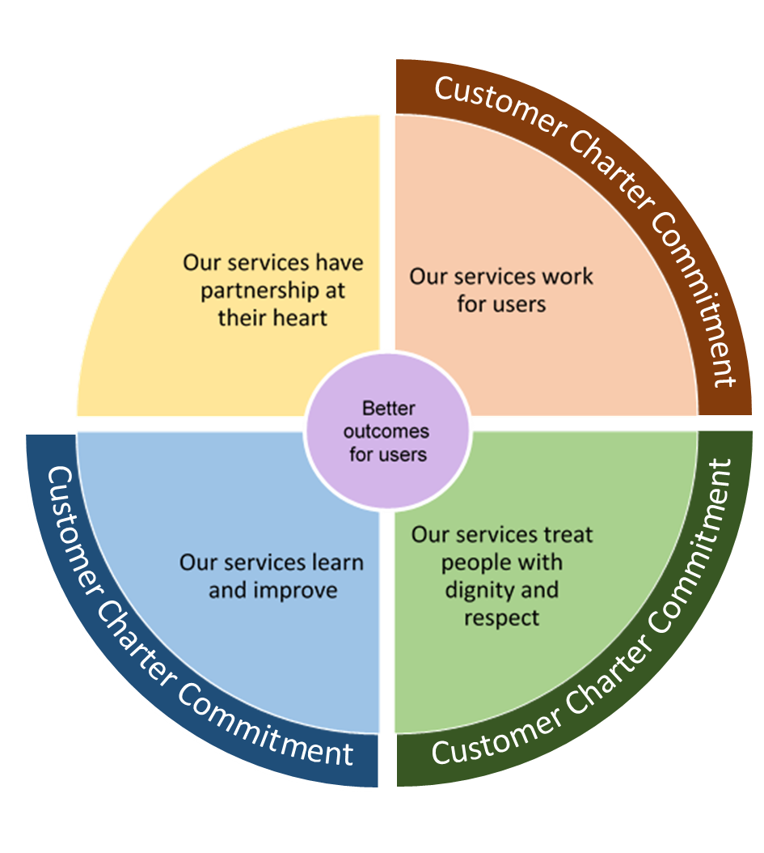
The Standards set out what we should all be looking to evidence through design and delivery of services through the No One Left Behind approach.

It is crucial that we have a level of consistency across Scotland without negatively impacting on local flexibility to deliver for people accessing services, or in a way that reflects local labour markets. The Standards below set out a number of expectations, but, partners can implement many of these in a variety of ways. Organisations should go further if there is the capacity and desire to do so.

Each Standard should not be viewed in isolation. There are areas of overlap, but delivered together, these are designed to achieve the common purpose of delivering better outcomes for users.

The diagram below demonstrates how each Standard is a necessary component of driving our collective ambition to deliver better outcomes for users of employability services.

These Standards are also designed to work with the Customer Charter and the Shared Measurement Framework. Taken together, these three products establish a shared view of what success looks like for employability services in Scotland and what is important.

Standard 1 - Our services work for users
 | Why is this important?
For services to work for users, people that use services and employers have to be involved from the earliest stages so that we can test our assumptions early and embed collaborative decision making into everything that we do.

Putting users at the centre of services is about more than simply consulting with them or assuming we know what will work best. It is about designing services with the people that will use them.

The Customer Charter sets out what users have told us they want from employability support, and helps us to understand what a person-centred service looks like. Working with users to understand their circumstances and delivering services in a manner that take this into account is critical, whether it is providing flexible options for engaging with a service, or supporting someone to access support that sits outside of the traditional sphere of employability.

There is also strong evidence to show that a dedicated key worker or single point of contact acting as a trusted professional is a critical element of a person-centred service, and the expectation of services delivered through the No One Left Behind approach is that this is built into the design. The expectation is for service users to have a single point of contact throughout their journey to help with building a trusting relationship, but that does not mean they should not engage with other people as and when required.

When carrying out research it’s important that we involve a wide range of people, be ethical and inclusive, and that we collect and process data legally.
 | Local Employability Partnership expectations | Service provider expectations
 | Embed the Scottish Approach to Service Design (SAtSD)  Local Employability Partnerships design the commissioning process in line with the SAtSD, and utilise inclusive tools, such as those set out in the Employability Service Design Toolkit. This includes open and transparent engagement with employers, service users and providers.  Map provision in your area  Take the time to understand how other services and support fits together locally and connect in practice. This information should be shared across the partnership to support providers in delivering expectations  Make sure evidence and data guide our decisions  Identify data and evidence which will help you make decisions, and opportunities for improving data and your evidence base. Data and evidence could include monitoring service data, qualitative evidence from users and staff and drawing from open data. Use the areas and key questions from the Employability Shared Measurement Framework to help generate actionable data and drive improvement.  Share insights  Communicate research findings and insights with your team and other organisations across the wider landscape who could use them, whether locally, regionally or nationally. | Services are designed with service user involvement  Providers design their services in line with the SAtSD, and utilise inclusive tools, such as those set out in the Employability Design Toolkit.  Provide a dedicated single point of contact for users  Service users should have the opportunity to work with someone that they can build a trusting relationship with. When support from another professional or service is required, the single point of contact should facilitate this.  Provide contact time that meets users’ needs  Time spent engaging with a service and intervention should be adequate to meet user needs, rather than delivered to meet a target. It is critical that the time allotted for this can flex in response to the person accessing support. This time can include interventions from other services and professionals, and may change as the user moves towards and into work.  Work with other organisations to address whole problems for users  Working to address barriers to employment can require input from a range of services that might not be seen as traditional employability support. We should view referrals and facilitating access to other services as a core part of our offer, and remain in contact with users in a way that meets their expectations throughout.
 | No One Left Behind Principles | How will we collectively assess progress?
 | Through delivering this Standard in line with the expectations, we’re supporting delivery of the following principles:  - A system that provides flexible and person-centred support  - Is driven by evidence, including data and the experience of users | Quarterly  - Shared Measurement Framework  Annual  - Annual Delivery Reports  - Independent evaluation activity  - Local Employability Partnership self-assessment activity

Standard 2 - Our services treat people with dignity and respect
 | Why is this important?
Often, those who need services the most, find them the hardest to access and use. Treating people with dignity and respect requires that they are active participants in the decisions that affect them, and that services are accessible to everyone that wishes to move into work.

No One Left Behind is not about supporting a narrowly defined user group, so our definition of accessibility has to cover a broad spectrum. From physical accessibility to digital provision - including specialist support such as for those who are deaf/ hard of hearing or experience sight loss, as well as materials in other formats or languages. Everyone should be able to use the service and have access to the specialist support #they require.

Accessibility also means people have to be able to find the service, and be able to access it regardless of their circumstances. Referral routes should be as seamless as possible where they are needed.

Services should also be flexible and consider what they can do to support accessibility for users, such as developing routes into harder to reach communities and groups.

Users have reported being frustrated by services that over promise and under deliver. It is critical that we recognise where our strengths lie, and that we support users to engage with other organisations that may be better placed to support an individual.
 | Local Employability Partnership expectations | Service provider expectations
 | Proactively engage those that are harder to reach  We need to ensure that those who are further from the labour market are specifically targeted by services. Actively considering how to engage with people and communities that are not well served by public services should be an integral part of service planning. Our services should be as simple as possible for users to engage with.  Actively design referral pathways and entry routes  Ensure services cater for a wide range of circumstances, whether that is referral from statutory services, users getting in touch directly to get support or signposting and introduction from another service. Partnerships should also consider outgoing referral routes to ensure we can get users the right support at the right time, and recognising that multiple services may require to be accessed concurrently.  Specialist services  Plan and commission for specialist support that is necessary to enable people to access services, and progress towards work. | The service user’s voice drives decisions that impact on their journey  Users are clear that being listened to is a key element of feeling as though they are being treated with dignity and respect. We should actively agree individualised action plans with users and not make assumptions on what might be best for someone.  Communicate with the user about their accessibility requirements  Understand what they want and need, what support can be put in place, and where engaging with another provider could enhance the experience of the service.  Provide users with a choice around how they engage  Take the time to understand what works best for the user and support this where possible. Remote meetings might work better for those that will face difficulty travelling, or different formats, aids or tools may be required to support others in accessing our services.
 | No One Left Behind Principles | How will we collectively assess progress?
 | Through delivering this Standard in line with the expectations, we’re supporting delivery of the following principles:  - A system that provides flexible and person-centred support  - Is more straightforward for people to navigate  - Is better integrated and aligned with other services, in particular, although not exclusively with health provision  - Provides pathways into sustainable and fair work  - Is driven by evidence, including data and the experience of users  - Supporting more people – particularly those facing multiple barriers – to move into the right job, at the right time | Quarterly  - Shared Measurement Framework  Annual  - Annual Delivery Reports  - Independent evaluation activity

Standard 3 - Our services learn and improve
 | Why is this important?
Services shouldn’t be static and unchanging – no matter how effective we are at delivering, driving improvement should be a priority. Service providers should strive to continuously improve on users’ experiences and outcomes when engaging with their services. Continually improving services is also entirely consistent with the SAtSD and the expectations set out under Standard 1 and 2.

Improving services should not be left to chance. It’s important to have a clear process in place to identify, plan and deliver improvements, and elicit data and evidence, including user feedback, to do so. The Continuous Improvement Toolkit has been developed to support us with this. Leaders should aspire to nurture an improvement orientated culture within their services and organisations, ensuring all staff are aware of their role and are empowered to drive improvements effectively.

Insight from users has also highlighted the significance of the people working in our services. Those delivering directly with users can have a profound impact on how someone perceives a service and whether they feel it helps them achieve their goals. As such we need to ensure staff working in services have access to the training they require and the support they need to develop high standards of practice. We also want staff to feel empowered, motivated, confident and valued. This requires leadership within organisations delivering No One Left Behind services to support a culture of continued learning, development, and reflective practice.
 | Local Employability Partnership expectations | Service provider expectations
 | Create the conditions for improvement  Providers need to be delivering in a context that allows them to drive innovation through improvements. Without having the right culture in place to achieve this, to feel comfortable with trying new approaches, failing, and learning, the effectiveness of continuous improvement will likely be limited.  Have a clear complaints and feedback process locally  We learn as much from things that don’t work as we do from those that do. Partners need to know when things aren’t working as much as when things are.  Spread Improvements  Delivering an improvement is no mean feat – when an improvement has been successfully delivered this should be celebrated and shared across services where possible. Learning and experience should also be shared more widely to spread improvement ideas across the employability landscape.  Establish training requirements  Identify the needs of your users and set expectations of training that support the workforce in your area to develop the skills to meet these. Thought should also be given to equalities and how awareness of different circumstances can be raised even in non-specialist staff. Feedback and input from staff should be encouraged in developing programmes of training. | Drive service level improvements  Resources devoted to driving improvement should be seen as an investment in service quality. Processes for staff to discuss, plan and deliver improvements should be built in, with freedom given for innovation and testing new ideas. It must also be recognised that this won’t always lead to an improvement, but that is simply part of the process.  Support personal development of staff  View personal development as a core aspect of the role and a necessary element of ensuring the workforce can deliver services that meet these Standards. This will require staff being supported to have space to reflect on their practice to identify areas for development, increase self-awareness and improve ability to deal with challenges in future.  Embed Lived Experience in training  Training shouldn’t be seen as a box to be ticked, but rather something that adds value to the service. Where training is focussed on the particular barriers or characteristics, support from advocacy or specialist organisations should be sought to ensure delivery embeds lived experience and does not replicate problematic practices.
 | No One Left Behind Principles | How will we collectively assess progress?
 | Through delivering this Standard in line with the expectations, we’re supporting delivery of the following principles:  - is driven by evidence, including data and the experience of users | Annual  - Annual Delivery Reports  - Independent evaluation activity

Standard 4 - Our Services have partnership at their heart
 | Why is this important?
The No One Left Behind approach requires partnership at every level to be delivered effectively. We are committed to a mixed economy of provision, with local partners being able to access funding that may previously have been inaccessible as a result of contract sizes.

Partnership also extends to the national partnership, with the expectations of working between Scottish Government, Local Government and Employability Partnerships defined by the Partnership Working Agreement.

We also have a responsibility to contribute to wider public service reform agendas, including reducing duplication. Strategic planning and commissioning is required to achieve this.

 | Local Employability Partnership expectations | Service provider expectations
 | Organisations work across boundaries  Planning at a local level should be strategic so that ways to work across boundaries are identified, and duplication of effort is reduced, in line with the Christie Commission. Boundaries can be defined as service level, sectoral, geographical, governmental or all of the above.  Approach commissioning from a partnership perspective  All Local Employability Partnerships must commit to a mixed economy of provision between sectors, and ensure relevant statutory bodies are consulted and engaged in developing local commissioning priorities. We should strive to hide the wiring behind our services so that processes are straightforward and easy to navigate for users, providers and employers.  Share learning and good practice  Learning from what others are doing has a role to play at the local, regional and national levels. Partners should be encouraged to engage with mechanism for sharing this knowledge, whether through local groups such as Local Employability Partnerships, or national forums such as Knowledge Hub (exact processes TBC). | Ensuring that “Every Contact Counts”  We should all view ourselves as part of a wider landscape of delivery and work alongside other providers to provide joined up packages of support and integrated pathways. It is critical that “Every Contact Counts” in driving both engagement with employability services and ensuring that those accessing employability services are supported to identify and access the holistic package of support they need to move successfully towards and into work.  Raise awareness of your specialism  If we are to deliver effectively in partnership, we need to understand where specialisms lie in local areas. Communicating with other providers and ensuring we only retain clients we are well placed to support is critical in achieving better outcomes.  Be open with learning  Learning from what others are doing has a role to play at the local, regional and national levels. Partners should be encouraged to engage with mechanism for sharing this knowledge, whether through local groups such as Local Employability Partnerships, or national forums such as Knowledge Hub.
 | No One Left Behind Principles | How will we collectively assess progress?
 | Through delivering this Standard in line with the expectations, we’re supporting delivery of the following principles:  - A system that provides flexible and person-centred support  - Is better integrated and aligned with other services, in particular, although not exclusively with health provision  - Provides pathways into sustainable and fair work | Annual  - Annual Delivery Reports  - Independent evaluation activity  - Local Employability Partnership self-assessment activity

How the Standards fit with other products

The Service Standards form part of a wider national framework of products that have been designed to support delivery of services under the No One Left Behind approach. Taken together, they collectively drive our aim of achieving better outcomes for users, and establish a common view of what success looks like, and what is important in Scotland’s employability system.

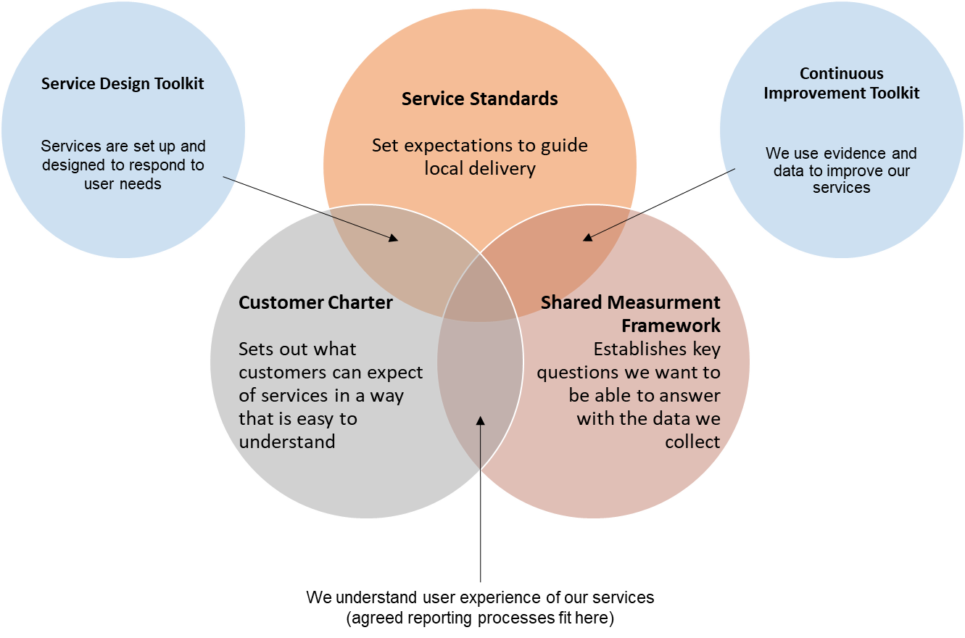

The Customer Charter is designed for a user audience, establishing commitments services should meet through their delivery. By aligning the Standards to this document, we are not only using user insight as a basis for understanding how we should be looking to deliver services, but increasing our chances of delivering effectively on the Charter commitments by ensuring they are embedded in how we collectively define a quality service.

The Shared Measurement Framework will support a shift from separate approaches to measurement for different employability programmes, to a coherent view of what is working for people at a national, local and individual service level. The data gathered through the SMF will drive our understanding of how well we’re meeting these Standards, highlighting areas where improvement may be needed. The themes and key questions established in the Framework read across all four areas set out in this document, with some explicit areas highlighted in the Standards above.

Our commitment to Continuous Improvement

Continuous improvement is not a responsibility that stops with providers of services. We are committed to embedding this approach at the national level too. Feedback on these Standards will be critical to refining them over time, and as narrative evidence from delivery begins to be reported in, wording of these Standards may require alterations to better support delivery.

Independent evaluation will also play a role in assessing how well the expectations set out in these Standards are understood and implemented.

As was the case with developing these Standards, alterations and improvements will be carried out in partnership, with the voice of providers and the wider partnership represented.

https://www.gov.scot/publications/fair-start-scotland-evaluation-report-3-overview-year-two/documents/

