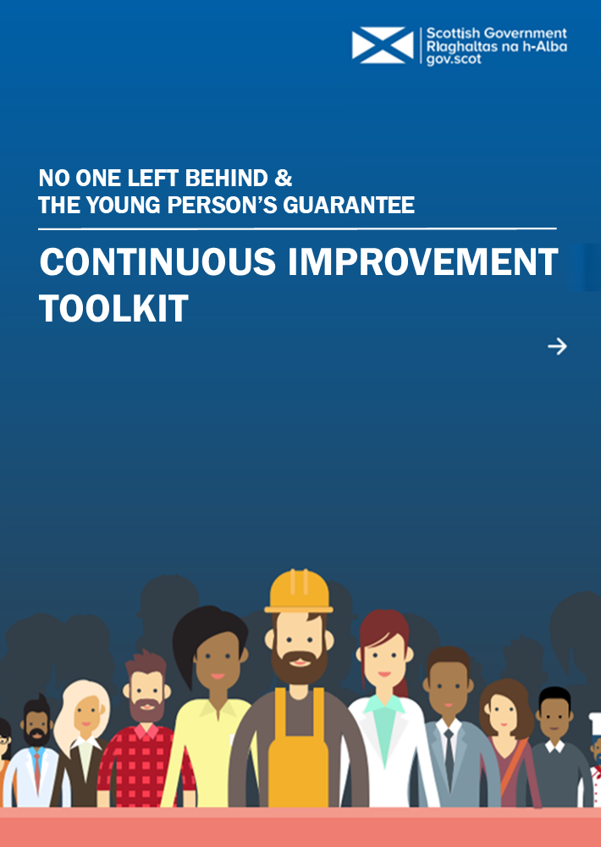
Introduction

Scottish Government, Local Government and partners in the third sector have taken direct action to develop services to support individuals into work through our collective approach to employability support services - ‘No One Left Behind’. Furthermore, to tackle the increased uncertainty posed to young people’s economic opportunities due to Covid-19, the Young Person’s Guarantee has been established, offering every 16-24 year old in Scotland the opportunity of a job, apprenticeship, further or higher education, training programme or volunteering.

Whilst developing these services will make a significant contribution to the lives of those who need our support to enter and sustain employment, it’s vital that they continue to improve and evolve in response to individual, employer and community need. Our emphasis on the importance of continuous improvement is long-standing, with ‘continuous improvement’ identified as a core value of employability support when we outlined our vision for a new future for employability support in Scotland in 2016. This commitment is entirely compatible with other commitments made as part of No One Left Behind, such as the commitment to the Scottish Approach to Service Design, which covers a range of activity, including live service delivery.

This toolkit is a resource which can support those delivering services to realise this vision, by providing them with tools and information that they can use to make improvements to services. This toolkit is not intended to replace nor compete with existing approaches to improving services that partners from across No One Left Behind or the Guarantee may be more familiar with, and is designed to be used as a complimentary resource.

What are we hoping to achieve?

The overarching aim of this toolkit is to support those developing and delivering services to continuously improve on the experiences and outcomes of those accessing and using employability support. Recognising the effective processes already in place to deliver improvements to services, the purpose of this toolkit is not to override these approaches with a new, uniform approach, but to add value to existing good practice. In developing this toolkit, we have learned from the advanced approaches to continuous improvement using improvement methodology across other sectors, such as healthcare, as well as within employability related initiatives such as the Health and Work Support Pilot in Fife and Dundee.

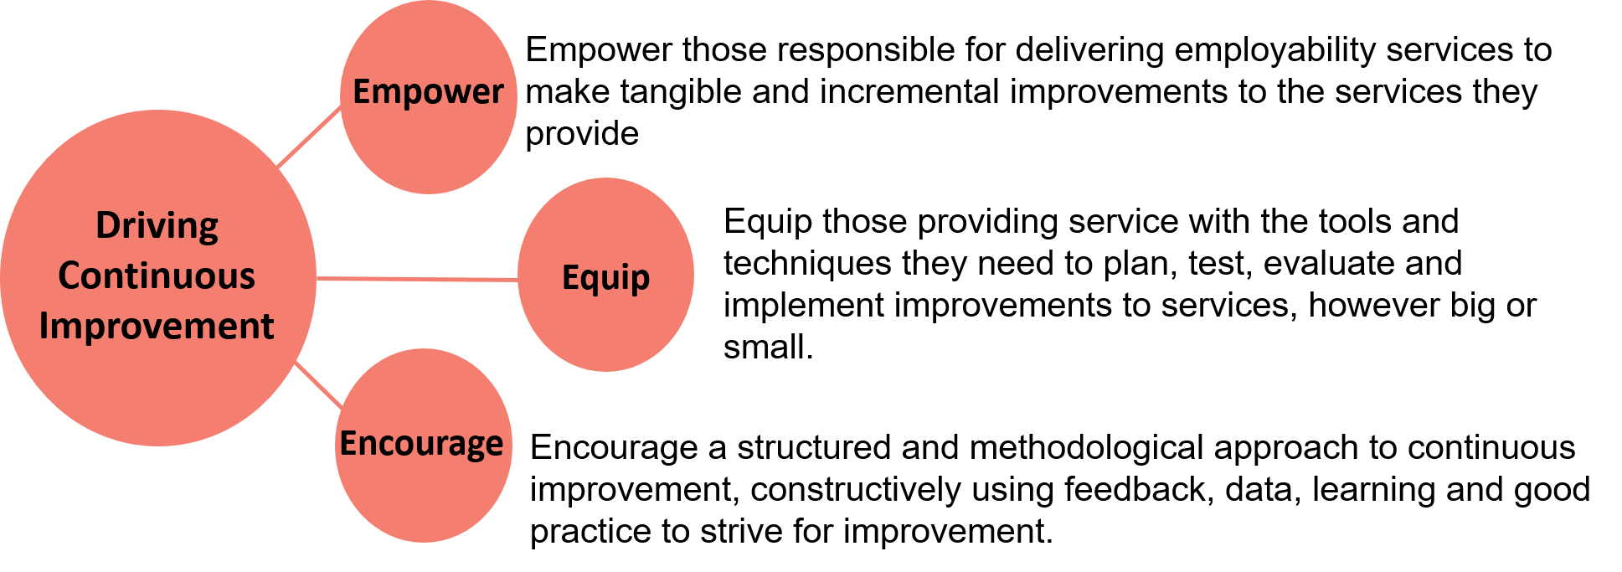
This toolkit will hold three main functions in driving continuous improvement within employability related services, by empowering, equipping and encouraging those delivering services, as outlined below.

Who is this toolkit for?

This toolkit has been developed by a short life working group, comprised of partners delivering services from across the employability sector, and is targeted towards teams and individuals responsible for designing and delivering services under No One Left Behind or the Guarantee.

This toolkit’s main function is to empower service delivery colleagues to make small-scale and incremental improvements to services. Those directly responsible for delivering services have a detailed and valuable understanding of how services are delivered and are performing, and therefore are uniquely well placed to make small-scale and incremental improvements at a service level. Over time, these small-scale improvements will accumulate, leading to substantial improvements to the experiences and outcomes of service users locally and nationally.

However, those directly involved delivering services are not solely responsible for delivering improvements, and everyone working within the sector has an important role to play in driving improvements to services. Developing this toolkit in collaboration with our partners is one way in which we are striving to play our part in supporting driving improvements to services, and we are committed to continuously improving on our role within No One Left Behind and the Guarantee. A high level overview of the roles that those working across the sector can play in facilitating the use of this toolkit can be seen below.

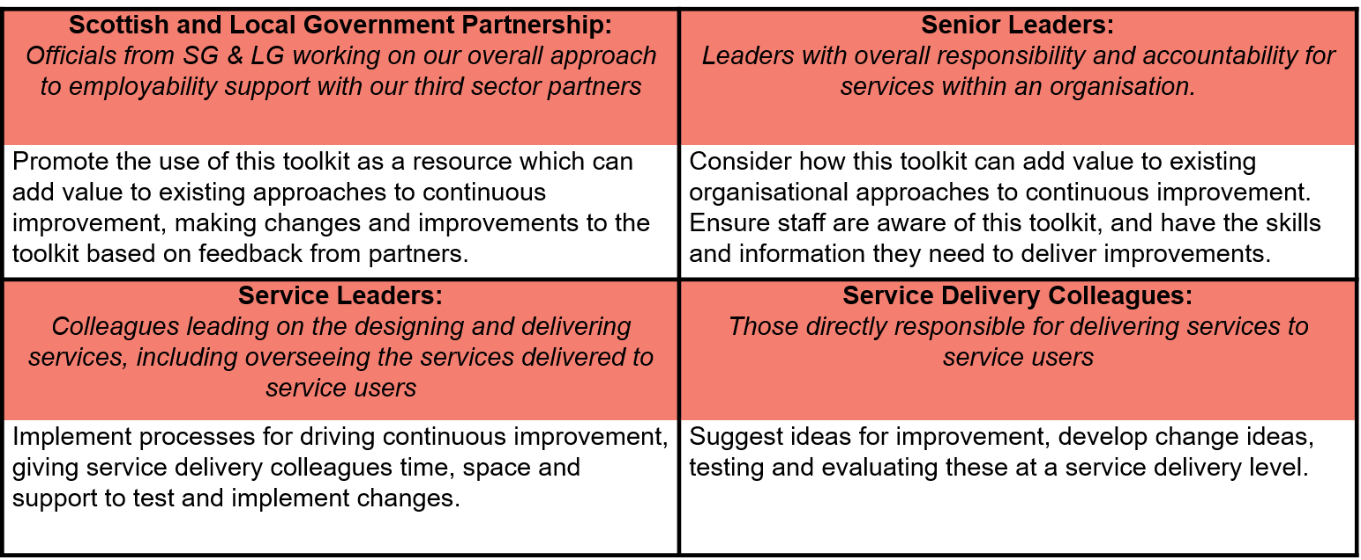

How is this toolkit structured?

This toolkit has been split into three main sections – Planning Improvements, Making Improvements, and Sharing Improvements. Each section contains a series of useful tools or procedures which partners can use at these various stages in an improvement journey. Those delivering services are encouraged to consider which aspects of this toolkit could add value to their own existing approaches to driving continuous improvement.

Ultimately, this will result in the toolkit being used differently by different organisations at their discretion. We anticipate this will be a particularly useful resource for smaller organisations who may not have the resources or capacity to invest in embedding improvement methodology into their organisations, however, we would also encourage larger organisations, who may have their own advanced and sophisticated approaches to driving continuous improvement, to consider how aspects of this toolkit can be used to add value to existing approaches.

Identify Areas for Improvement
(pages 5-6)
Use service user feedback, self-evaluation and data to identify where improvements are needed most within services

Sharing Improvements
Making Improvements
Planning Improvements
Share Best Practice
(page 11)
Use Knowledge Hub to share information and lessons learnt across Scotland
Test and Implement Changes – Plan, Do, Study, Act
(page 10)
Test change ideas at a small scale, and evaluate these to decide whether to adopt, adapt or abandon change ideas
Develop Change Ideas
(pages 7-9)
Use improvement tools to develop change ideas that could contribute to achieving an improvement aim
Create an Aim Statement
(page 6)
Create a concise, measurable and time bound aim statement, clearly articulating what is hoping to be accomplished
Planning Improvements

A structured approach to planning improvements should begin with developing robust processes for identifying areas for improvement through self-evaluation, analysing data, and collecting feedback from service users. These findings should be used to identify where improvement is needed most, and to develop clearly defined and measurable aims. These steps are described in more detail below.

Identify areas for improvement

Developing robust processes for identifying where there are areas for improvement within a service is an important way of ensuring improvement ideas and initiatives add maximum value. Those involved in delivering and using employability services should play a key part in the process of identifying areas for improvement.

Self-Evaluation

When self-evaluating the strengths and weaknesses of services, it’s vital to evaluate services against the objectives and desired outcomes of that service. To facilitate self-evaluation against the desired standard of service within No One Left Behind, a Self-Evaluation Survey template has been developed. This can be used by teams involved in designing and delivering services to assess whether or not they’re achieving the collectively agreed desired standards outlined in the ‘No One Left Behind National Service Standard Framework’. For best results, it’s recommended that teams complete this survey in collaboration, to ensure that the reflections and observations of all team members are taken into account. Teams involved in delivering services are encouraged to use and revisit this survey regularly to continually assess their performances to identify and prioritise the areas most in need of improvement.

For services not delivered under No One Left Behind, service providers are encouraged to consider how they can evaluate their services against the desired service standard in their area, and to establish processes for collaborative and evidence driven self-evaluation. This blank self-evaluation survey template is provided for service providers to input their own desired service standards, which they can then self-evaluate against.

Analysing Data

Analysing data can be an invaluable way of identifying the strengths and weaknesses of a service, and therefore identifying which areas are in most need of improvement. Multiple data sets are available for partners to use to measure and evaluate their services, ranging from local labour market statistics to management information. Over coming years, the Shared Measurement Framework for employability services will be developed, providing a consistent approach to measuring the reach and effectiveness of employability services at national, local, and individual programme level. This framework in particular will provide a useful resource for those providing services to identify areas for improvement. Providers across No One Left Behind and the Guarantee are encouraged to take full advantage of any available data sets to analyse the outcomes of their services, and to identify which areas of their services would benefit most from improvement.

In addition to using an organisation’s own data to identify areas for improvement, where data is being collected consistently, benchmarking data with similar organisations across Scotland can provide a useful insight into how a service is working. Where consistent data sets are being collected regionally or nationally and are available to those delivering services, we would strongly encourage that this data is used to gain a deeper understanding of where a service’s strengths and weaknesses are.
Service User Feedback
Ensuring employability services meet the needs and requirements of users is at the heart of our approach to employability support. Collecting and analysing feedback and insights from service users can be a vital way of identifying which improvements will have the biggest impact on their experiences and outcomes. Those providing services are encouraged to use robust processes for collecting regular feedback from service users. This can be done through tried and tested techniques such as surveys, interviews, focus groups and lived experience panels, as well as new innovative approaches that organisations may be using locally. These will provide an invaluable source of data to use to identify where a service can be improved.
Create an Aim Statement

Identifying where improvements can be made is only the first step in an improvement journey. After identifying an area for improvement, it’s strongly recommended that an improvement ‘aim statement’ be developed. An aim statement should be a concise sentence composing of the following three elements:

- What will be improved – i.e. what is hoping to be achieved
- How much of an improvement will there be
- When will the desired improvement be delivered by

Below is a good practice example of an aim statement which has been adapted from one used by a service participating in the Health and Work support pilot in Fife and Dundee, who were focussing on employer engagement:

‘By 30th June 2019, a cohort of 12 manufacturing SMEs will have moved 1 point along our employer engagement scale."

It’s also important that an aim statement is measureable. Whilst developing an aim statement, colleagues should consider what data they need to tell them whether or not the desired improvement has been achieved.

Making Improvements

After identifying the areas most in need of improvement, teams can collectively develop change ideas that could lead to improvements, testing these iteratively, to see if they do deliver improvements before being fully implemented. This section includes a series of tools and procedures that can be used by teams to put this into practice.

Develop Change Ideas

Once an area for improvement has been identified and an improvement aim statement has been developed, potential change ideas that could lead to improvements need to be generated. To ensure a breadth of ideas and insights, it’s recommended that change ideas are generated by a whole team where possible. For each improvement aim statement, it’s strongly recommended that a ‘driver diagram’ be developed. The purpose of a driver diagram is to identify which systems or processes within a service can influence whether or not an aim will be achieved. This allows you to pinpoint which parts of a system needs to change or be improved upon to achieve an improvement aim statement, so that you can target change and improvement ideas towards those processes. A driver diagram template can be seen below, with a blank template and further information on how to complete a driver diagram included in this guidance document.
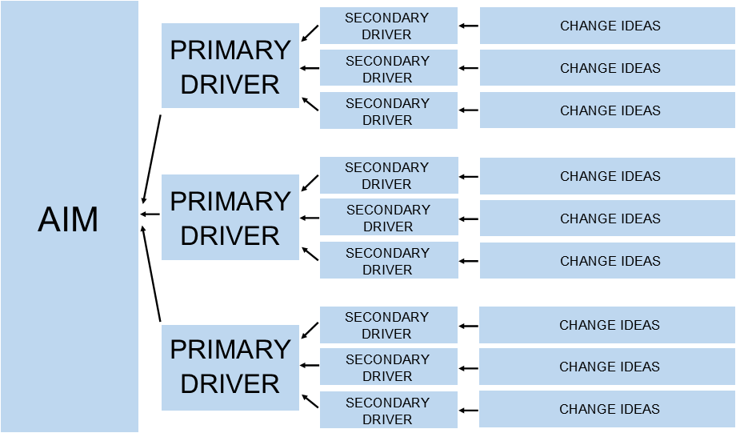

Over the next two pages, there is information provided on a series of tools that can be used when generating change ideas, allowing those who use them to gain a deeper understanding of a system, a type of user, or to understand the root cause of a problem which needs addressing. Whilst these tools can often seem unfamiliar or complicated, they are designed to be straightforward to use in practice. These tools are tried and tested and have been used to deliver effective improvements across multiple organisations and sectors worldwide. Further guidance on how to use these tools is included in supplementary guidance documents, which are signposted throughout this section.

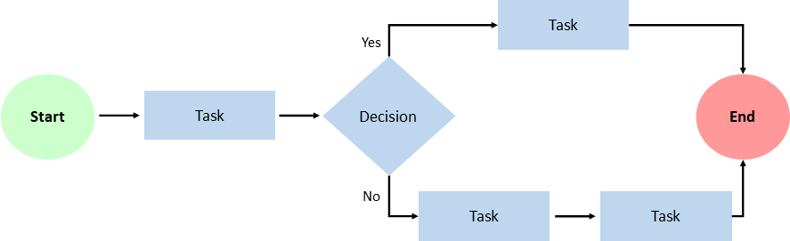
Process Map: A process map is a planning tool which can be used to articulate how a particular process within an organisation works in practice, supporting teams to identify areas where a process can be simplified or streamlined to improve on efficiency.

Why use this tool:
- To capture and visually represent all the steps in an existing process
- To ensure everyone in a team has a shared understanding of how a process works in practice
- To help identify where change ideas could make improvements through simplifying or streamlining a process
- To visually represent a new process

Guidance on how to use this tool is included in this guidance document.

Empathy Map: A collaborative tool teams can use to gain a deeper insight into a particular type of service user.

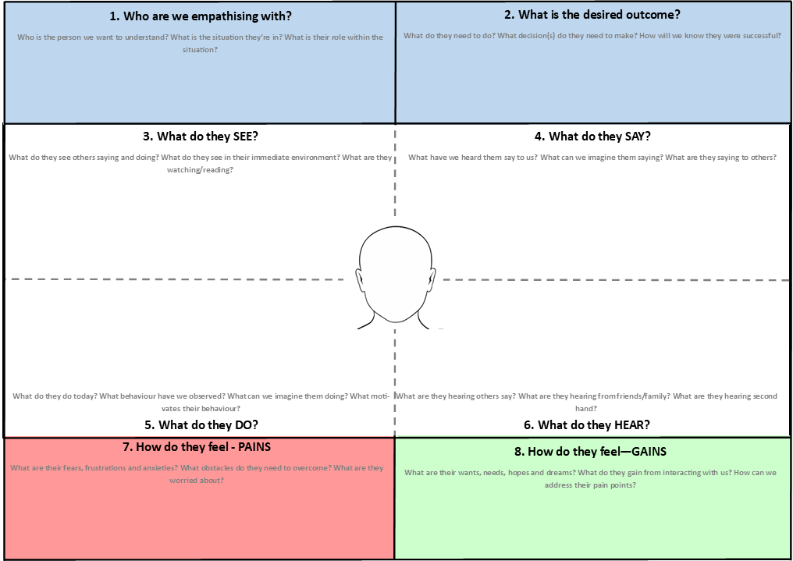
Why use this tool:
- To gain a deeper understanding of the attitudes and behaviours of a particular type of service user
- To support teams to make decisions and design services in a way which is of most benefit to service users
- To inform change ideas, ensuring that they will have a positive impact on the experiences and outcomes of users

Guidance on how to use this tool is included in this guidance document.

Cause and Effect Diagram: This tool can be used to help identify all the likely causes of a problem, and to facilitate developing change ideas which target the causes of a problem.
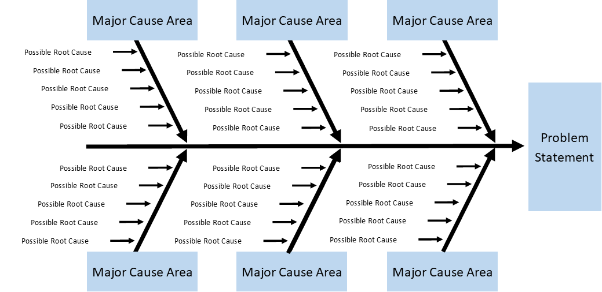

Why use this tool:
- To allow a team to explore the possible reasons, root causes and possible solutions for a problem
- To visually represent the reasons, root causes and possible solutions for a problem
- To help identify change ideas that target the root cause of a problem

Guidance on how to use this tool is included in this guidance document.

Force Field Analysis: After developing a change idea, a Force Field Analysis can be used for assessing the various forces for and against a proposed change.

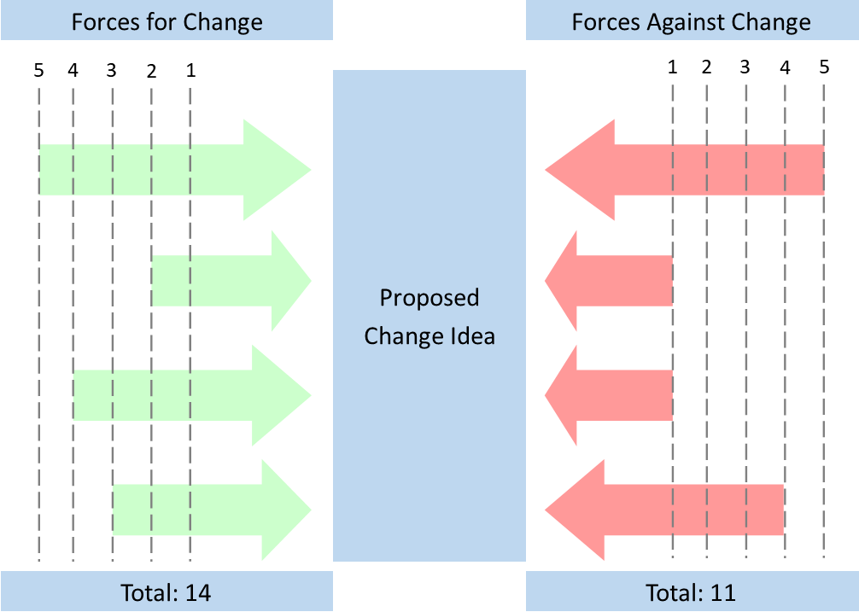
Why use this tool:
- Identify the pros and cons of a potential change idea
- Support teams to decide whether or not a change idea should be implemented
- Allows teams to identify which factors must be addressed and monitored if a change idea is to be successful.

Guidance on how to use this tool is included in this guidance document.

Test and Implement Changes – Plan, Do, Study, Act

Once a change idea has been identified, this idea should be tested at a small scale, and evaluated to see whether or not it leads to an improvement. To put this into practice, it’s highly recommended that a Plan-Do-Study-Act (PDSA) Cycle be used. This is a tried and tested approach used for testing an improvement idea at a small scale to assess its impact, before implementing successful improvements at a larger scale. This cycle is not necessarily designed to deliver large scale transformational change, but rather to deliver incremental and continuous improvement over time. A high level overview of the tasks involved in each part of the cycle is included below, with further details included in this guidance document.
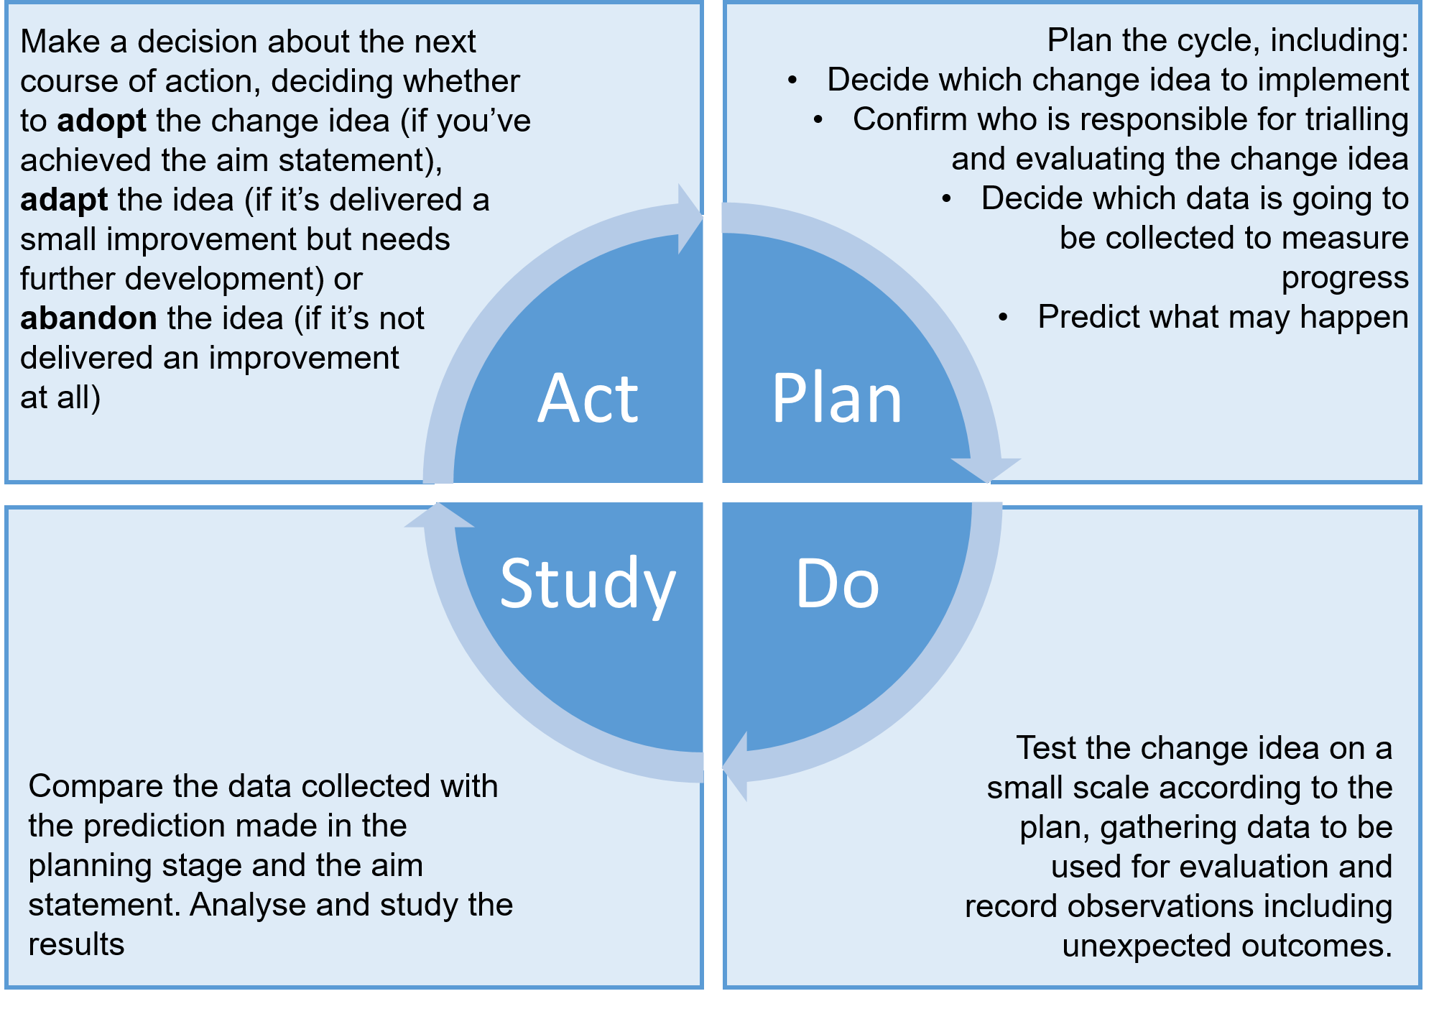

In order to log and monitor ongoing improvement activities within a team or organisation, it’s encouraged that this Continuous Improvement Action Plan template be used to co-ordinate improvement activities and log the key information relating to the improvement activity. This includes the improvement aim and desired outcome, how the success of the initiative will be measured, and the timeline for delivering an improvement. Teams delivering services are encouraged to use this action plan at their discretion, and to amend or build on the template as appropriate.

Share Improvements

Delivering an improvement – however big or small - is an achievement that should be celebrated and shared with other organisations. Sharing learning and experiences across organisations breeds innovation, encouraging those delivering services to build on each other’s improvements. We are developing a digital platform, which those delivering employability support services can use to share information about successful improvement initiatives.

Digital Platform - Knowledge Hub

Once improvement initiatives have been successfully implemented, there is much value to be gained through sharing best practice and lessons learned, providing information on the impact and outcomes of an improvement initiative. This will allow colleagues across Scotland to replicate and build on improvements successfully delivered elsewhere.

To facilitate sharing information quickly and efficiently, we are developing an online platform on Knowledge Hub which can be used for sharing information, good practice and lessons learned across the employability sector. This platform will reduce duplication of effort by encouraging service providers to learn from and build on each other’s work. All organisations involved in delivering services under No One Left Behind and the Guarantee will be invited to join the platform, and will be encouraged to use the platform constructively to share information about improvement initiatives across Scotland. The platform will include:

- a “library” area where documents can be searched for and downloaded with ease. For example, users will be able to upload examples of continuous improvement tools they have completed as case studies
- a message board area for conversation threads to allow for interaction between service providers
- a feedback mechanism to allow partners to suggest ideas of how this toolkit can be improved upon

We encourage those involved in delivering services to use this platform to share case studies and best practice. This will reduce duplication of effort where more than one organisation may be seeking to make similar improvements, allowing other organisations to build on improvements delivered elsewhere. In particular, this will be a valuable resource to smaller organisations which may have limited resources and capacity to devote to continuous improvement.

Promoting Collaboration

Often, the problems faced by those delivering services will be similar in nature, or will be too significant for one organisation to solve on its own. Where these problems occur, we encourage those delivering services to use the Knowledge Hub to discuss problems and share information. In addition, existing fora at local, regional and national levels should continue to be used to share information and collaborate. To build on this, where common or significant problems arise, we will explore further at a later date what we can do at a national level to facilitate collaboration between organisations delivering services under No One Left Behind and the Guarantee. In the near future, we hope to seek partners’ views on establishing procedures that would allow multiple organisations to collaborate and co-develop solutions for some of the most challenging problems faced across No One Left Behind and the Guarantee.

Please note that this self-evaluation survey is a separate exercise to the annual Local Employability Partnerships Self-Assessments. In contrast to the LEP Self-Assessments, we would encourage this survey to be completed independently by teams directly involved in delivering services, and would recommend this survey is revisited more than once annually to achieve the best results. These surveys are discretionary and findings can be utilised in a way that best meets the organisation’s needs.

