There are variety of static social images that you can use across Facebook, Instagram, and Twitter. We have included suggested copy to make promoting Fair Start Scotland as simple as possible. Social copy and social assets can be mixed and matched to suit your needs.

- Post:
Whatever your challenges, whatever your goals, Fair Start Scotland will support you in your search for rewarding work.

(117 chars)

- Post:
Fair Start Scotland is a flexible employment service that helps people thrive personally and professionally.

(108 chars)

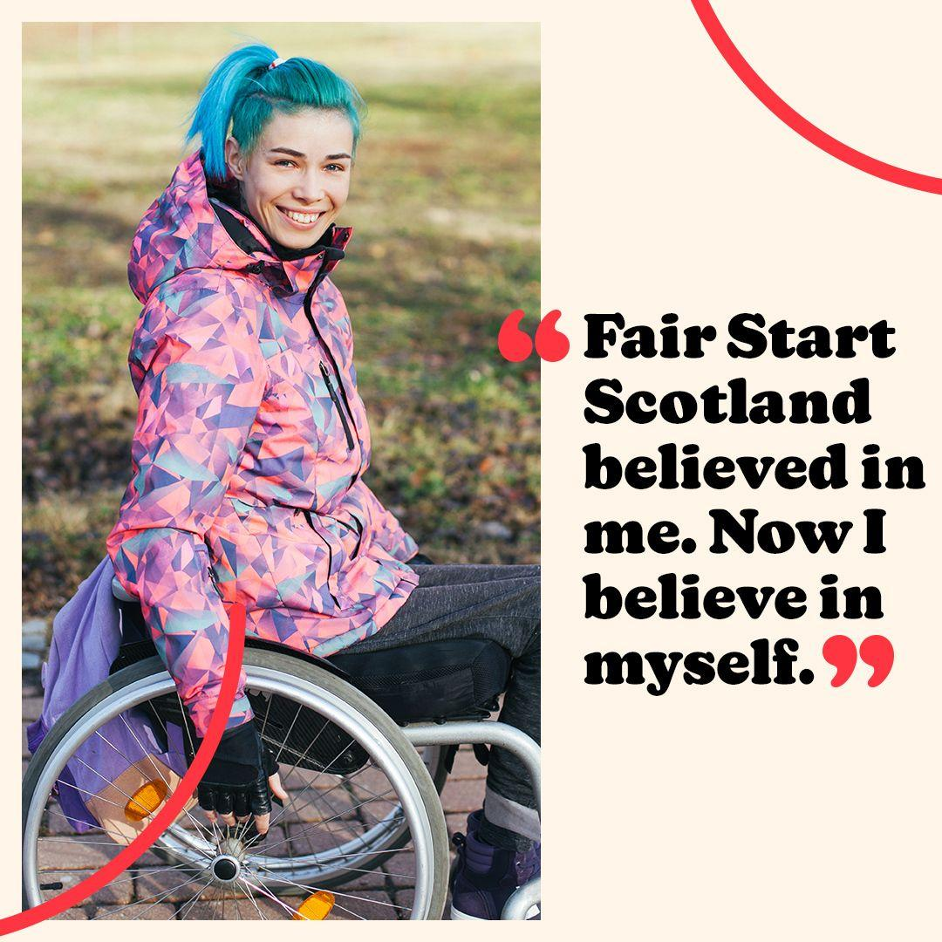

- Post:
Everyone is worth their place in the world of work. Fair Start Scotland helps everyone to realise that and act on it.

(117 chars)

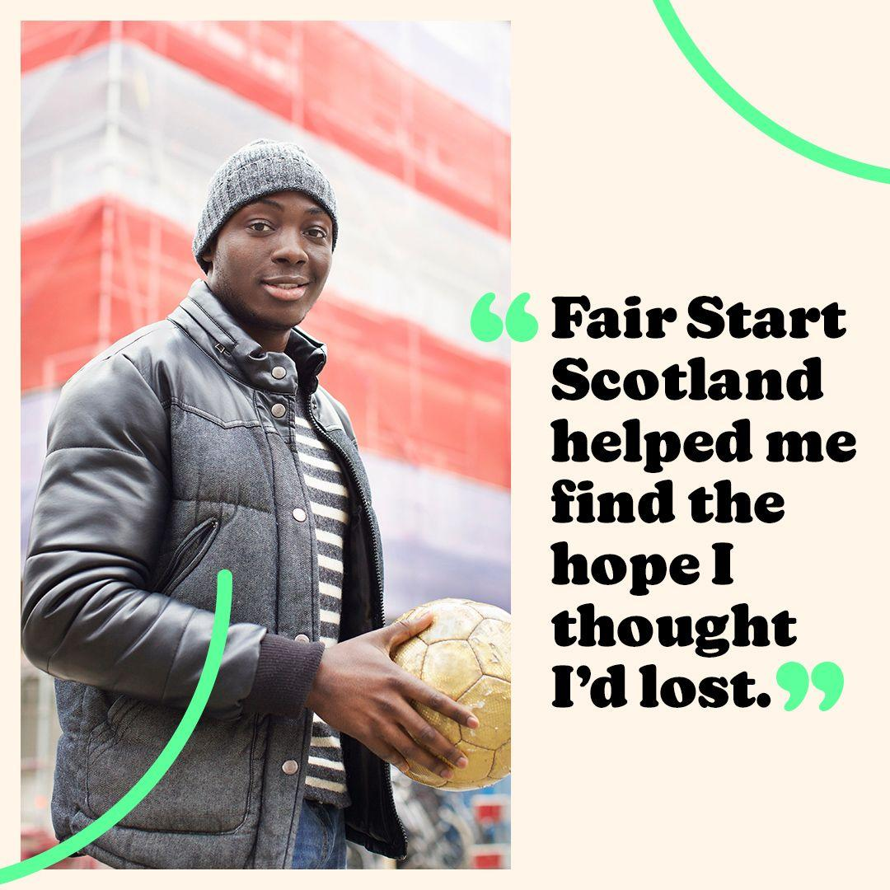

- Post:
Fair Start Scotland is a flexible employment support service, tailored to help individuals discover their talents.

(115 chars)

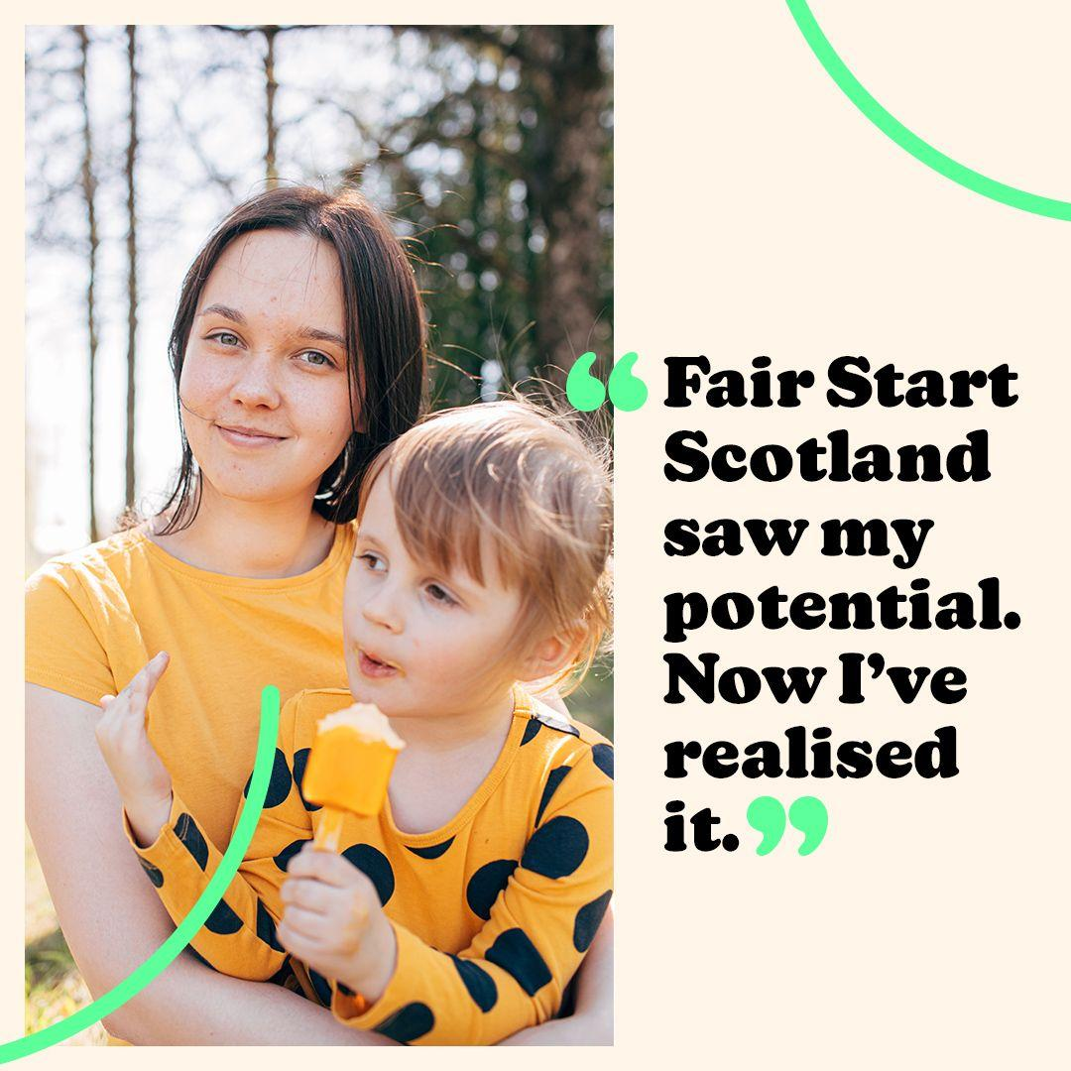

- Post:
Fair Start Scotland knows that when it comes to finding work, sometimes all people need is a little attention and direction.

(123 chars)

